DAG | CL᠂BR
 | DOVER ARCHÆOLOGICAL GROUP
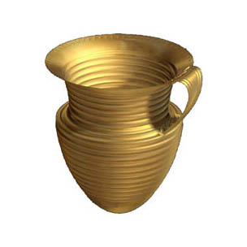

June 2018
Newsletter No. 9 © DAG 2018
A quarterly roundup of the Group’s activities and news

A Newsletter

Welcome to the June Newsletter,

This edition I’ve shamelessly taken the room to bring you a Special from pictures of Canterbury Cathedral but not perhaps, as you have seen it before.

The pictures are in two parts; the first are views from up on high, a place few people have seen except from the ground looking up. The second is this quarters CPD of mason marks on the Cathedral Caen stone.

Until my current work at the Cathedral I had no idea how ethereal masons marks can be. In a flat light they can be almost invisible. Using a light from the side marks appear almost by magic, add a second diffused light from below and finely etched sharp images appear. When I arrived in early April colleagues from CAT had been cleaning the roof space above the Nave, during three months they had recorded over 850 masons’ marks, it was quite staggering. I realised that when looking a tool marks on cut stones in plain sight there were many others we might not see straight from the ground because they are so finely tooled. Any such stones we find are always worth a second look.

So we start with a trip to the ‘site’ via a 12 story set of stairs and take in the views on the way. I hope you enjoy!

The work consisted of cleaning above the Nave and them me surveying the condition of marble columns in the Triforium, the North Quire with Andrew Savage who took in depth photos of their condition. Outside an Oculus window was spotted which was blocked off. This is situated on the North side appearing in the side of a buttress of the Bell Harry central tower. Heather, the head conservationist called it ‘the Devils window’…

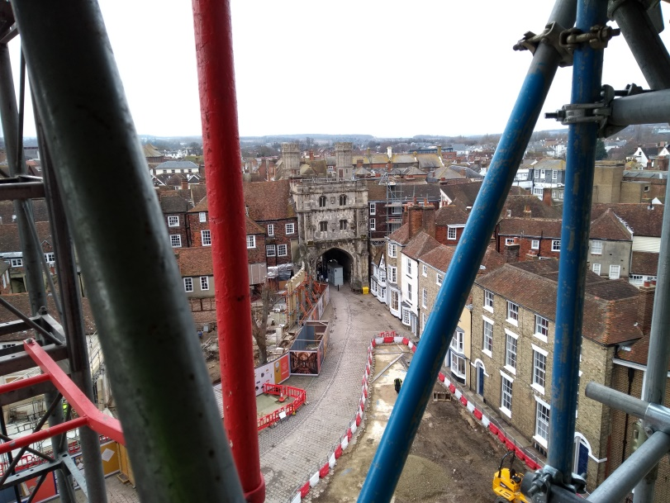
The Main entrance and the dig on the site of the new visitor centre
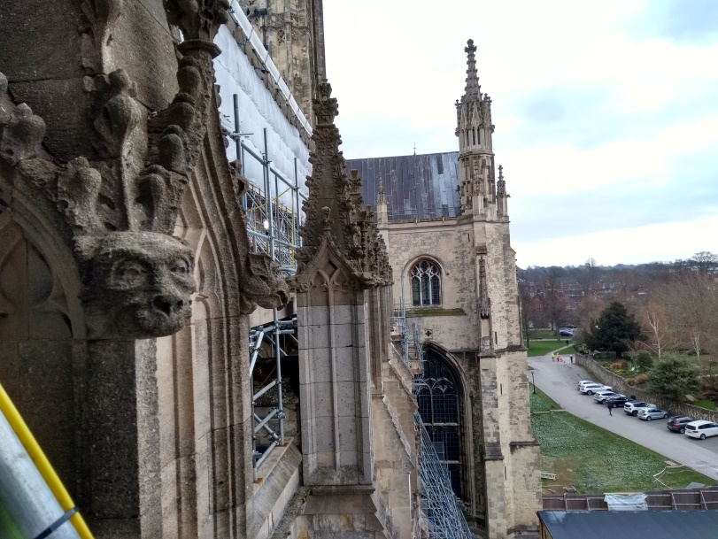
South side gargoyle

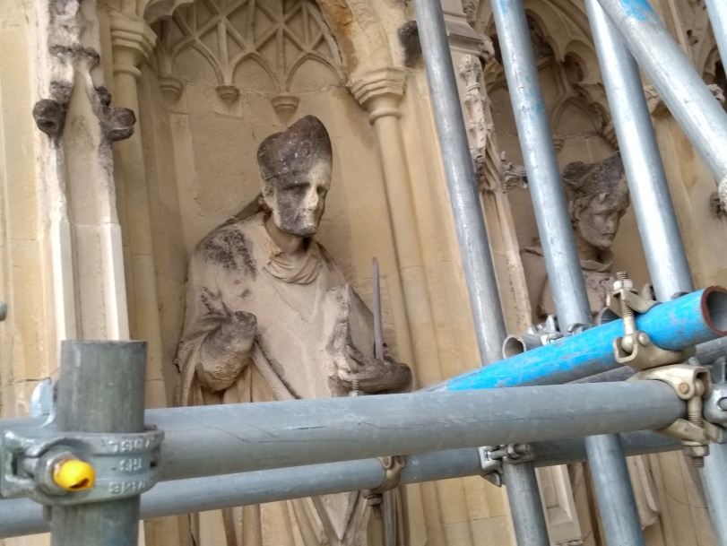
The Bishops view
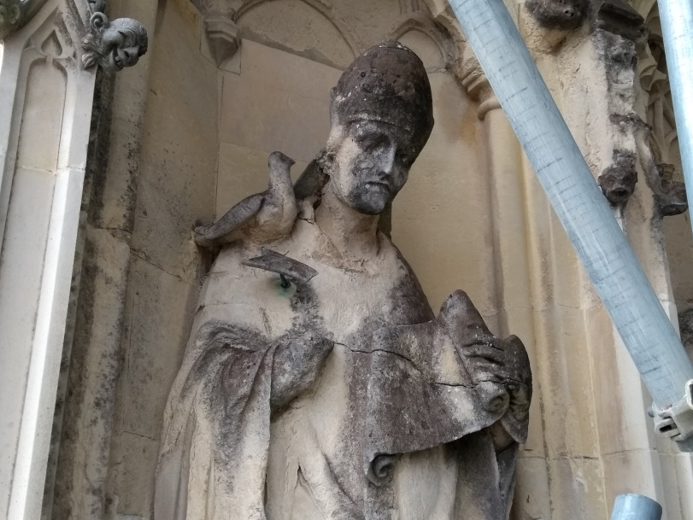
The Dove from Above

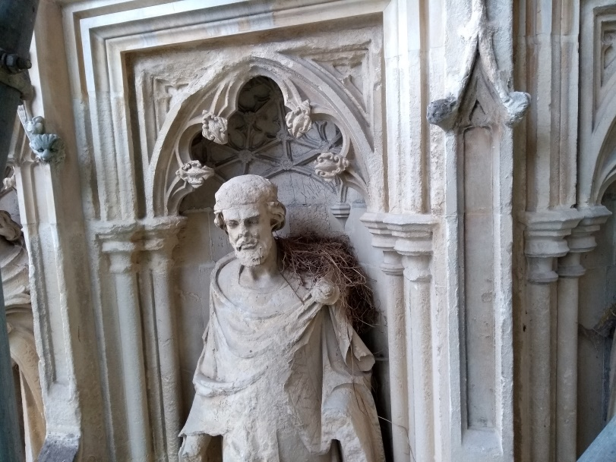
One for Geoff

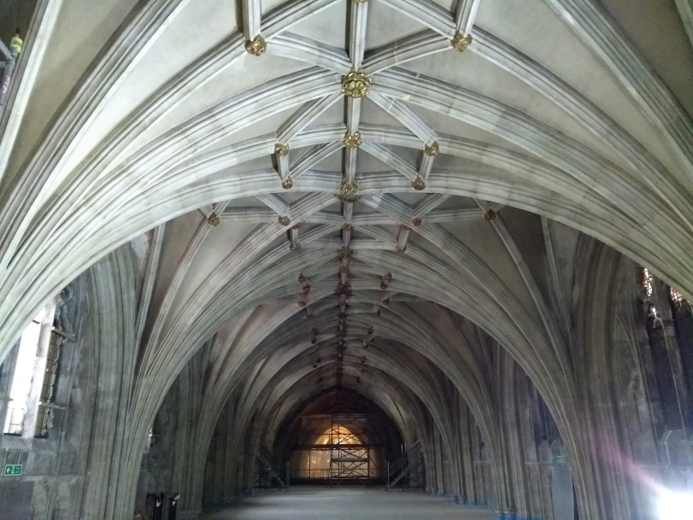
The area of site 1, the Nave’s vaulted ceilings
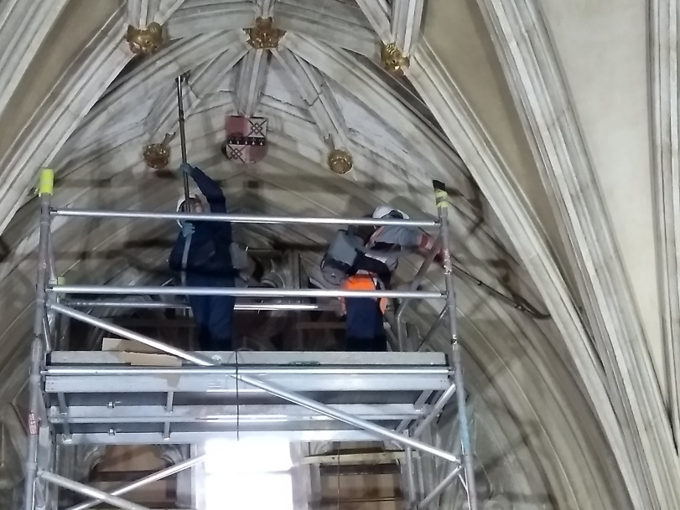
Girls, Alex and Esta hard at work

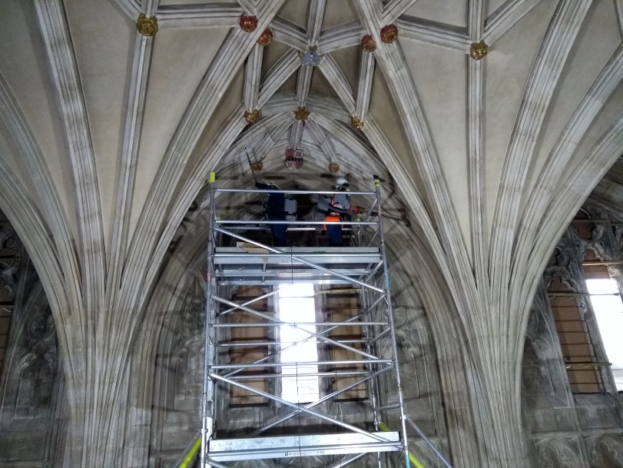
Do you like heights they said…
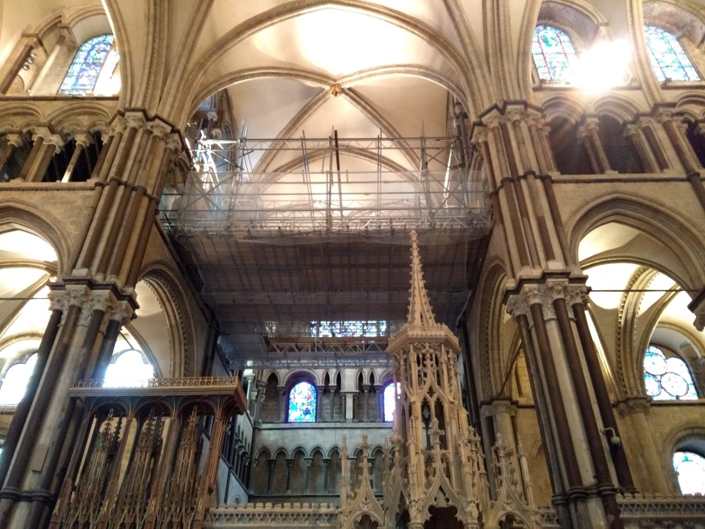

My Office

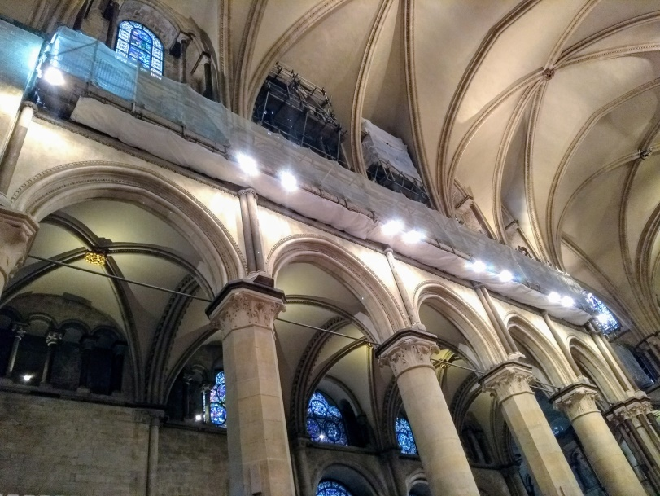

The North Quire
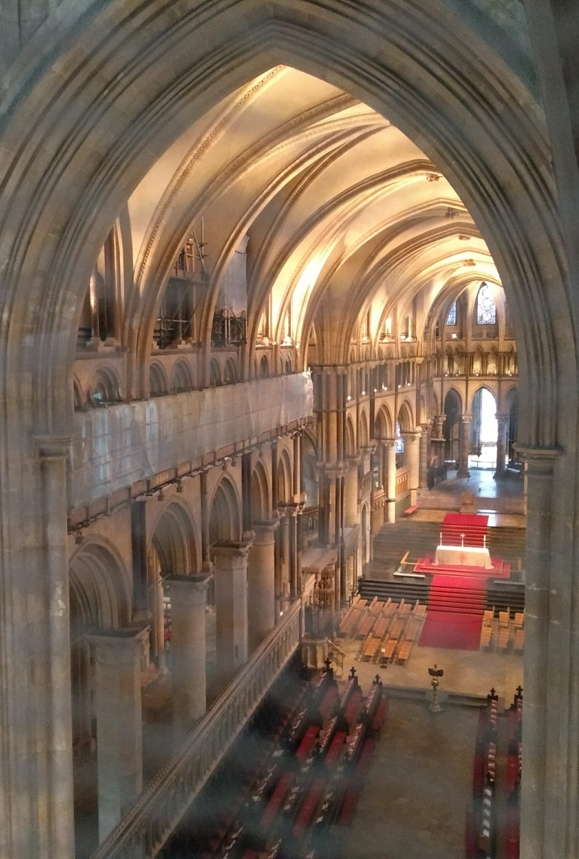

View of the High Alter from site 1 (through the safety netting Keith)
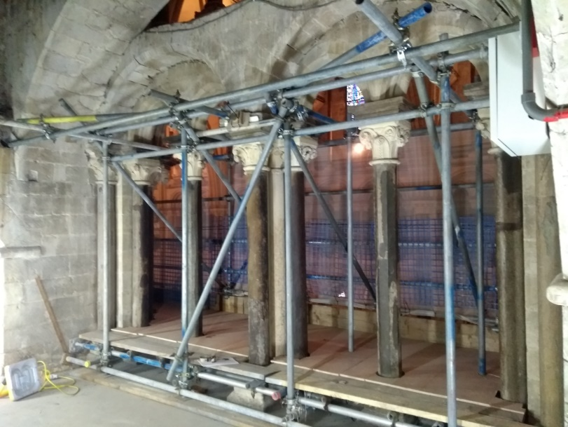

Site 2, the marble column survey

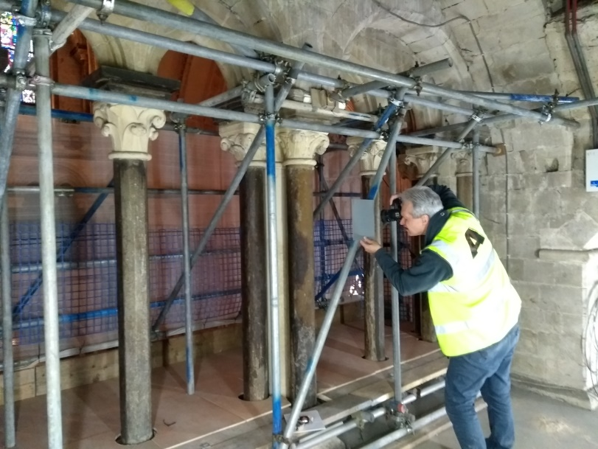
Andrew hard at work

The reveal of the Oculus window

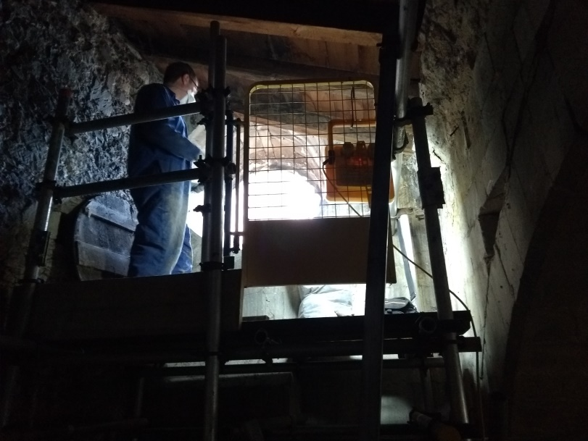
The wooden cover removed after at least 200 years.

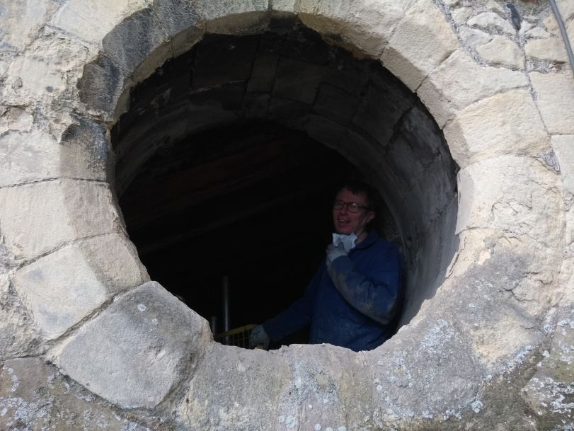
Let there be Light!
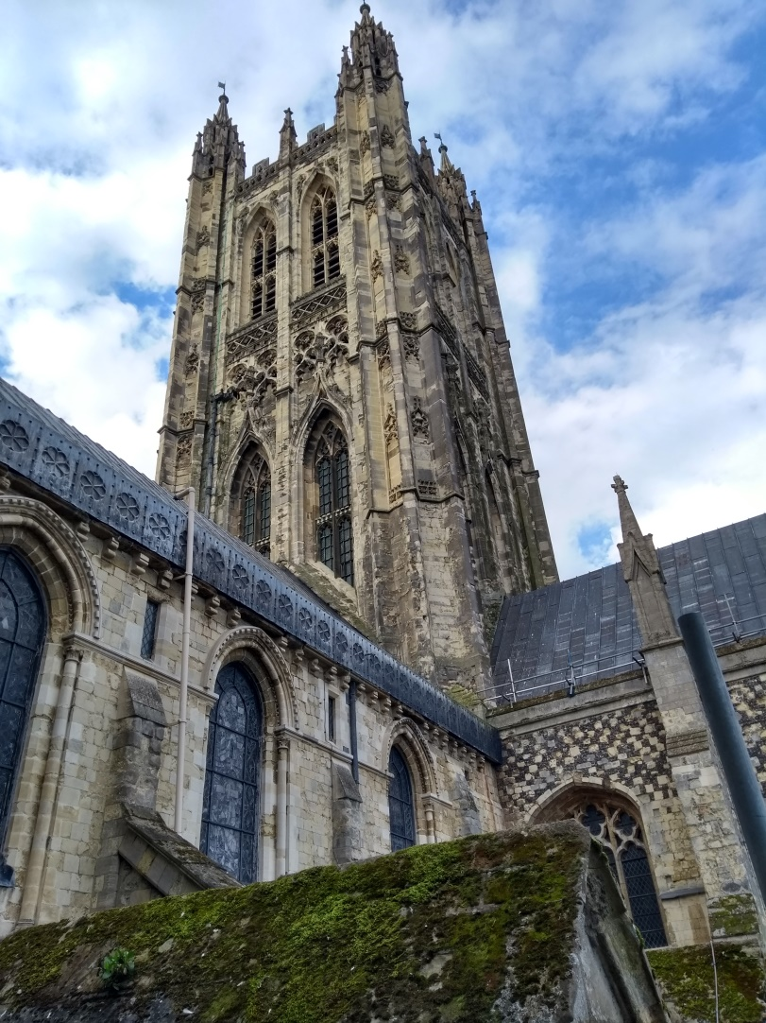

Bell Harry and the buttress to the right of the picture where the oculus was found.

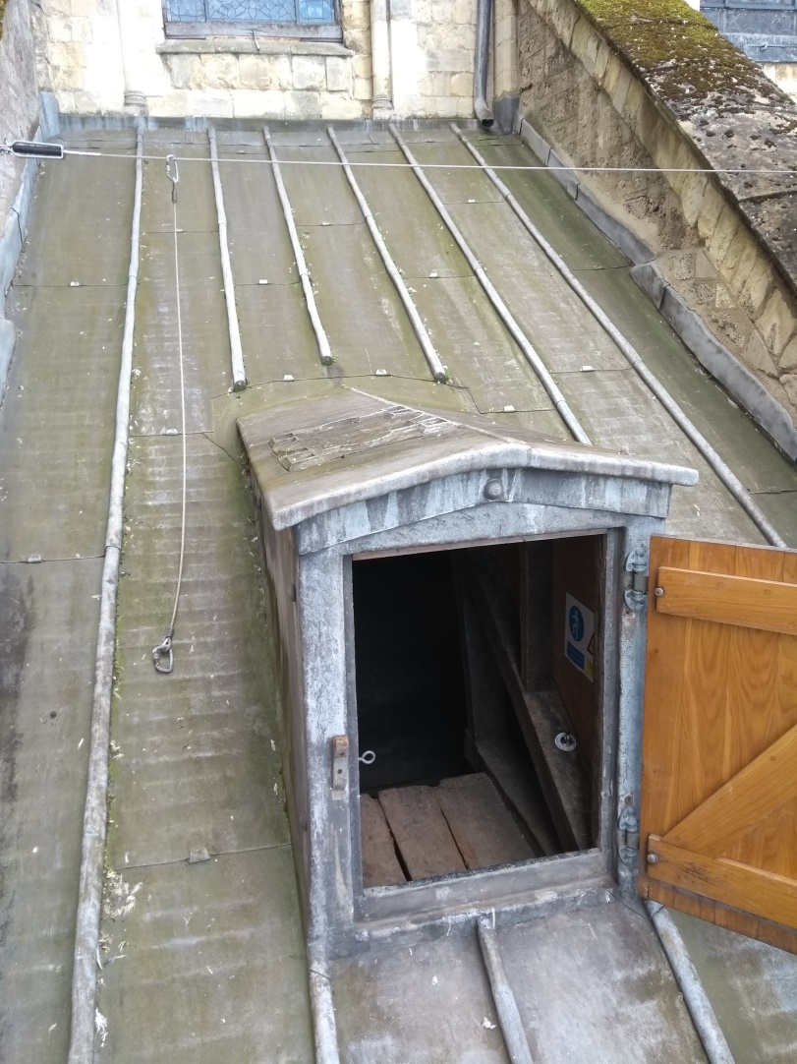

The north side roof exit from the Quire. Note the inscription on its roof.

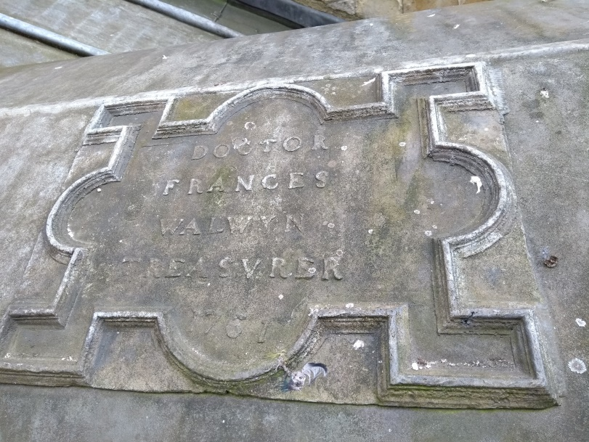
A dedication to the Canon Treasurer dated 1761

Mason marks from the North Quire –
Our Quarterly CPD

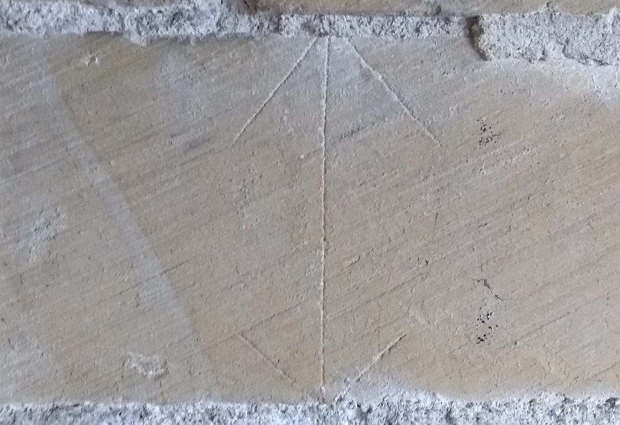
Some are exact and carved with care
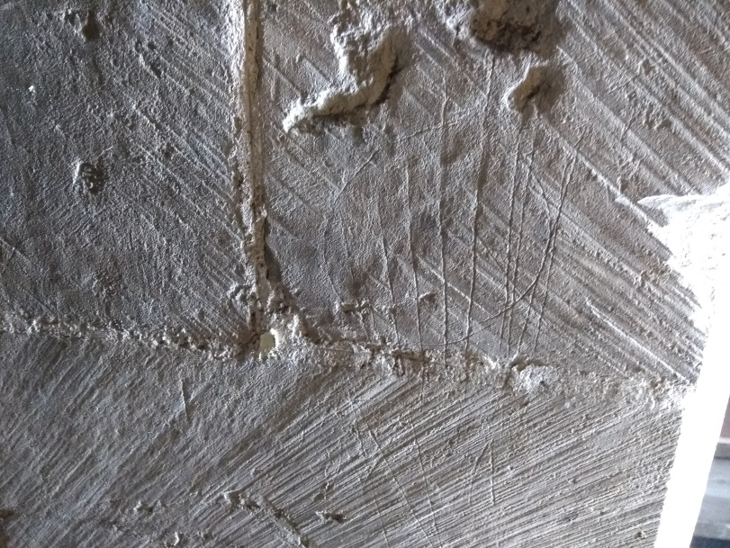
Some complex
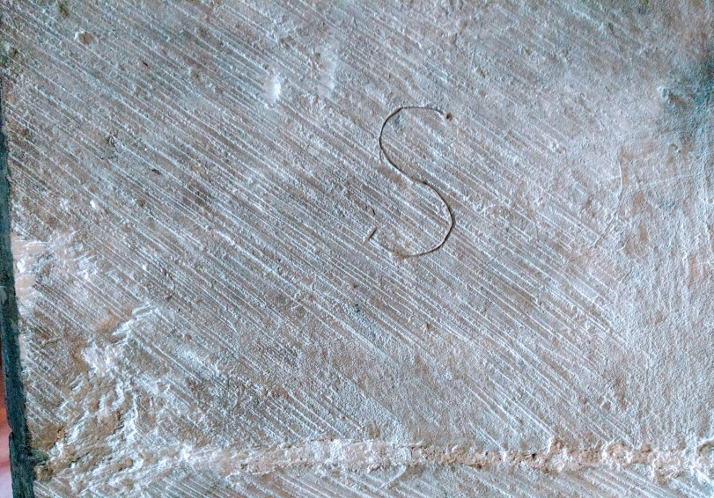

Some Simple
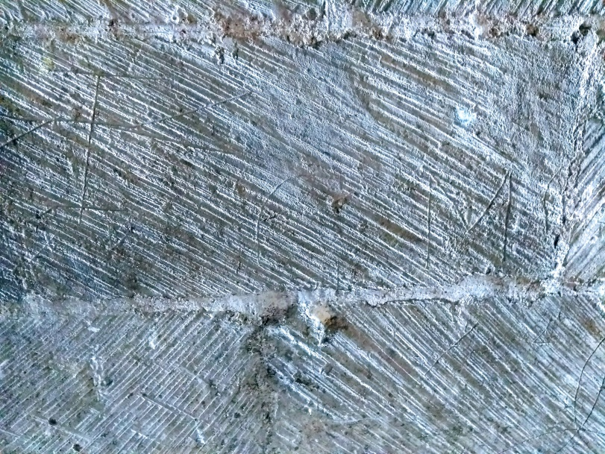

Two lights on it are better

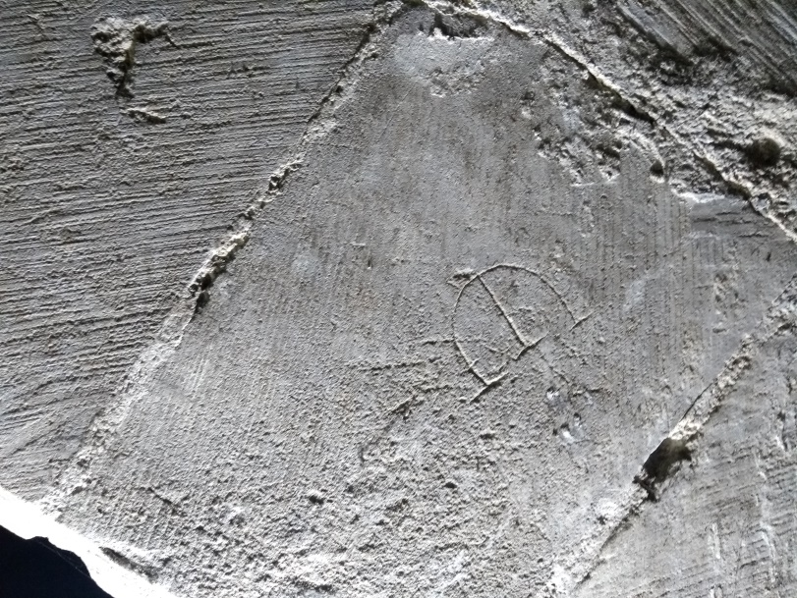
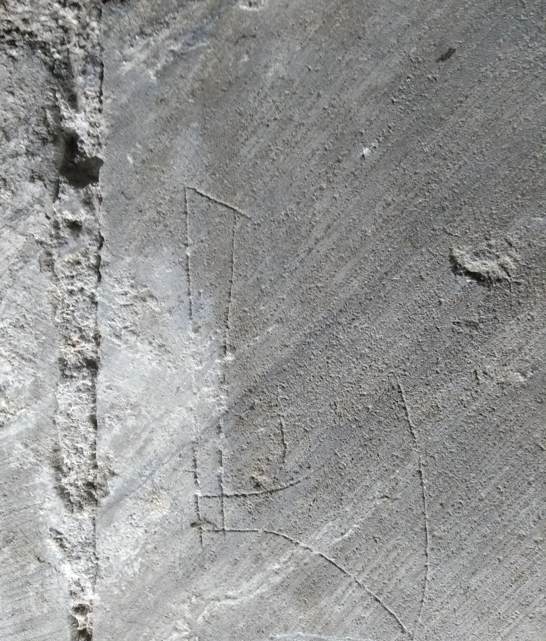

Some show history, the axe above is not only a personal symbol but dates to the Norman period when masons used a sharpened hand axe to cleve the stone before the chisel became accepted later.

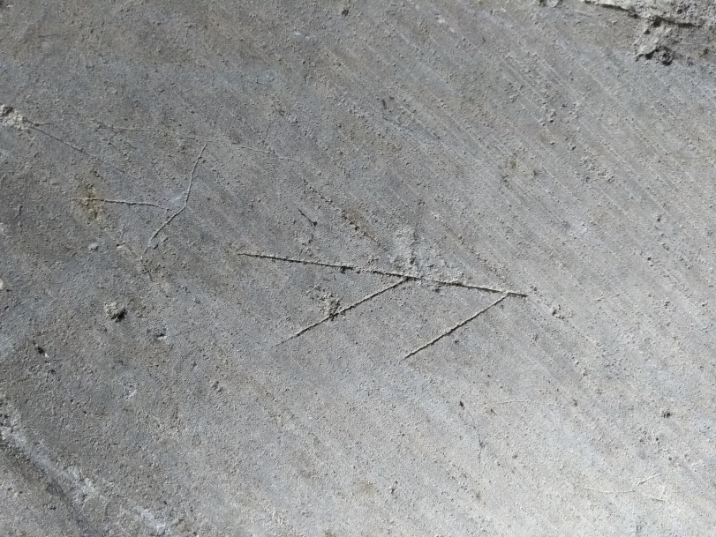

The shapes are almost endless, the number of masons endless.

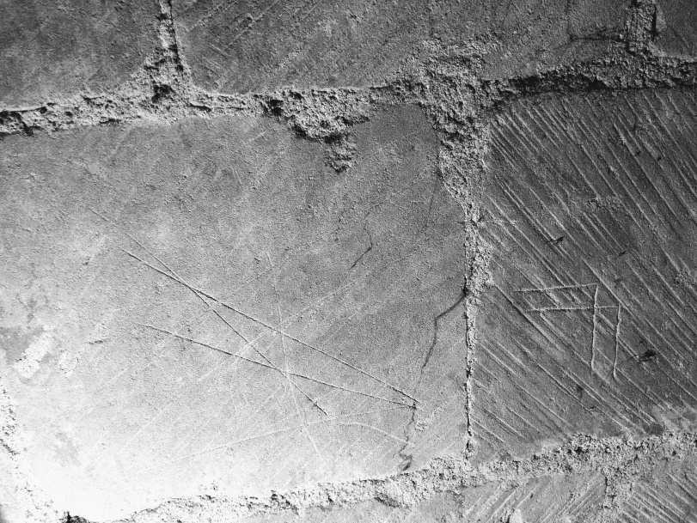

Some adopt geometric shapes and angles

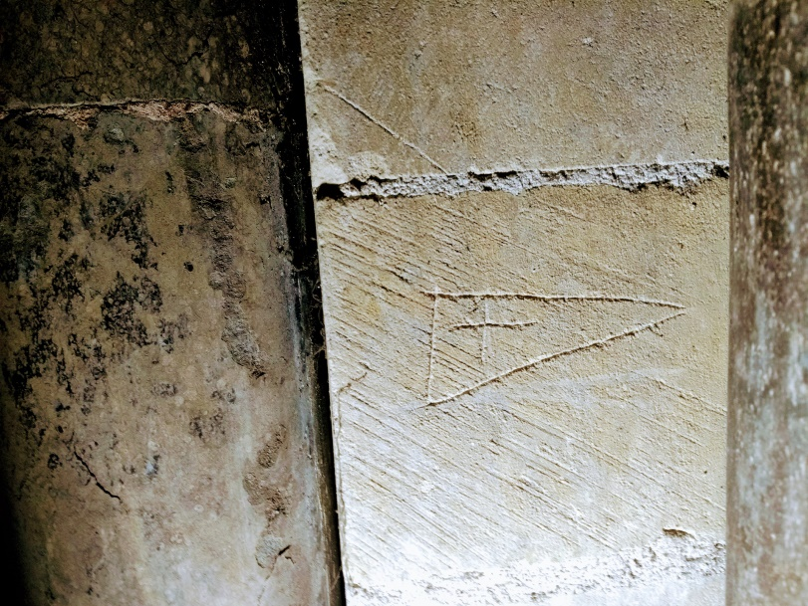
A cross on a pennant, who knew!

The sample of mason marks date from between 1120 and 1140 when the N Quire was built.

Andrew Savage - In memorium

Since writing this piece, sadly Andrew Savage passed away after a very short illness. Some of you would have met him at East Ear Bay when he lectured on pottery found on the site and provided an insight in the IA pottery we had found. He is sorely missed and he will be very hard to replace.

And finally, some of the amazing windows from up on high, the last picture was taken about 85ft up in the NE Transept.

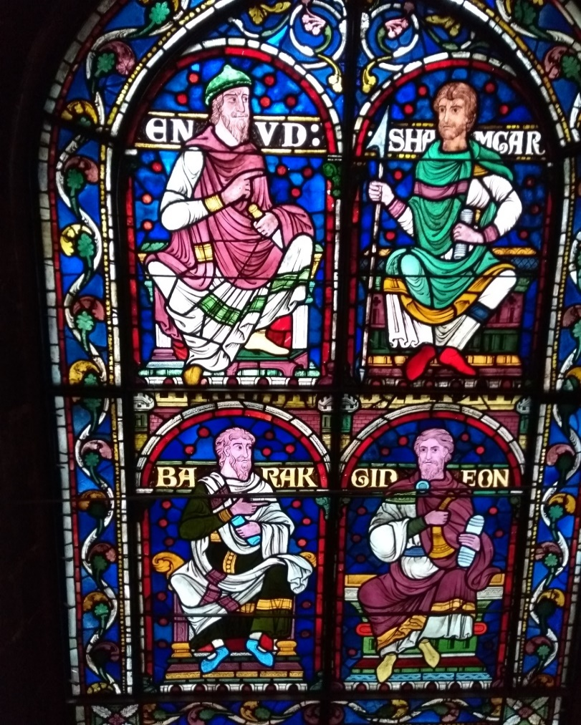
The last one, well it’s a surprise to all but is outside on the North wall of the N Quire. Where else can you find a Pelican nesting and feeding her chicks!

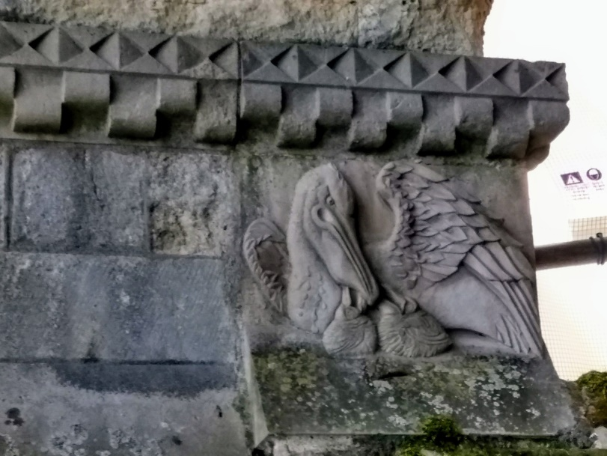
The Coxhill Barrow, Kearsney Abbey

Over two weekends starting on 14th and 15th April DAG assisted a community dig on Coxhill to investigate what we believed a couple of years ago as a possible Bronze Age barrow. Keith wearing his CAT hat held an introductory lecture the week before at Dover museum to the assembled volunteers to give them a background of the prehistoric landscape in the area and to prepare them afterwards with a walk to the barrow so they all knew what they were letting themselves in for!

Over the two weekends, including ourselves were 51 volunteers taking part. The first weekend revealed a 2m ditch and Nick drew first honours with a Neolithic axe seen below.

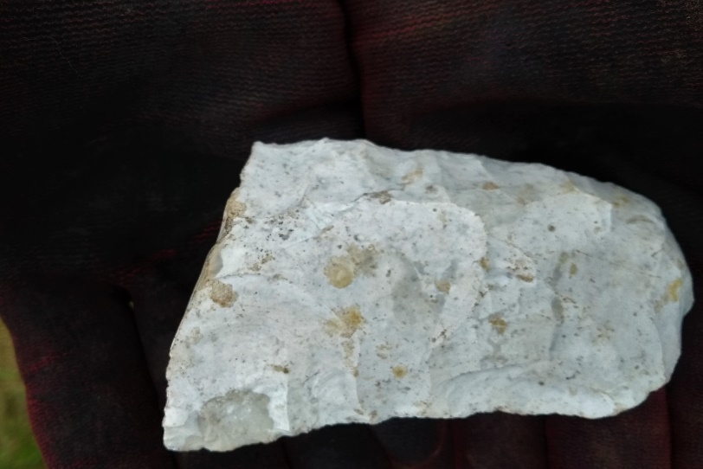

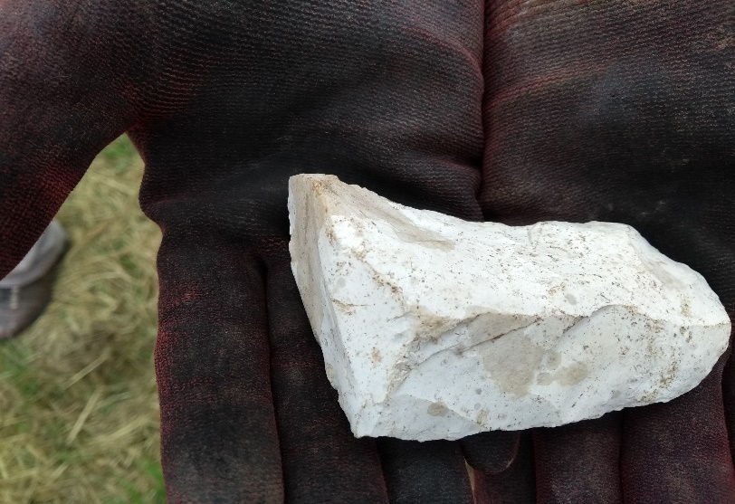

Gareth and the team worked hard to uncover the barrow ditch and Keith and Tina had honours of the drawing and planning.

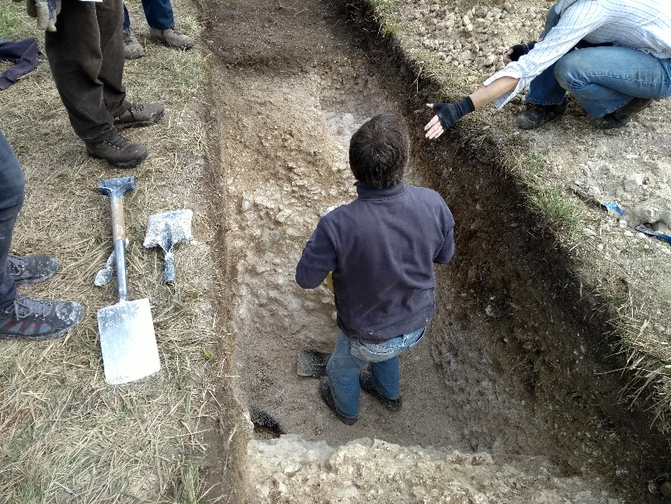

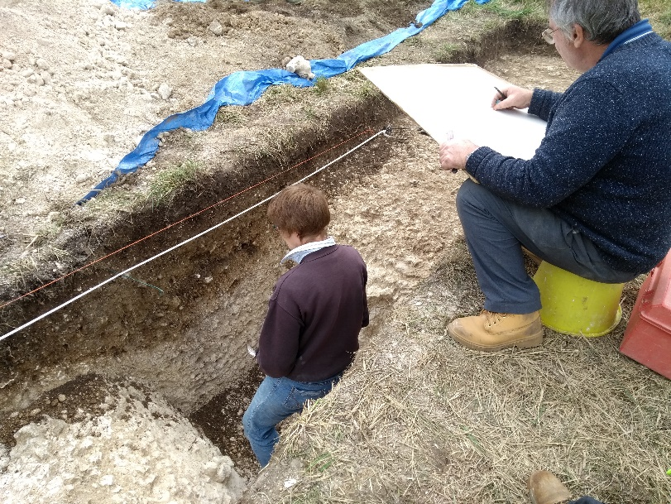

The second weekend having had the first go as well as it could, the second turned out slightly different with a pit cutting the ditch on the lower side which was stuffed full of struck flint. When I say struck it’s not necessarily flint in the traditional ‘struck’ sense. There appears at first sight that flint was being tested, large flint lumps being struck two or three times to see if the flint met the grade and whilst there have been several large cores of sorts they again seem part of this testing process rather than striking off blades or similar.

Current thinking is these flints are earlier than the BA barrow approaching Neolithic in date and its possible the flint was being harvested from the mound of the barrow several hundred years after its construction.

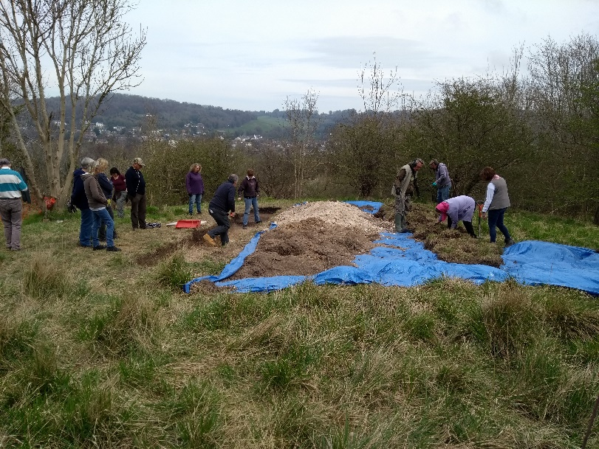
View from above looking East.

Pottery from the dig was identified by Nick and its date confirmed by Nigel McPherson-Grant as Neolithic Peterborough Ware, the Ebbsfleet variety c. 3350-2800BC.

All in all, it was a great success with the identification of a hitherto unknown Bronze Age barrow, we’ve pushed the history of the hill and Abbey grounds back some 5000 years and generated a following of archaeology by the local people at large. Which in turn will be publicised by the DDC Parks news team.

News from the Group

It’s been a long hard winter; the Group has been largely involved with the last recording and finds processing of the Nonington site to date. Culminating with processing CAT finds from Whitfield Leisure Centre and Deal Castle, both now published reports.

Last month saw the end of this work was in sight and in May after six months solid of finds processing and reporting assistance to Keith we saw the Group return to the original Nonington site. Firstly to locate the corner of the older building and second locate a ditch feature nearby. To everyone’s satisfaction both were located in just two weekends digging.

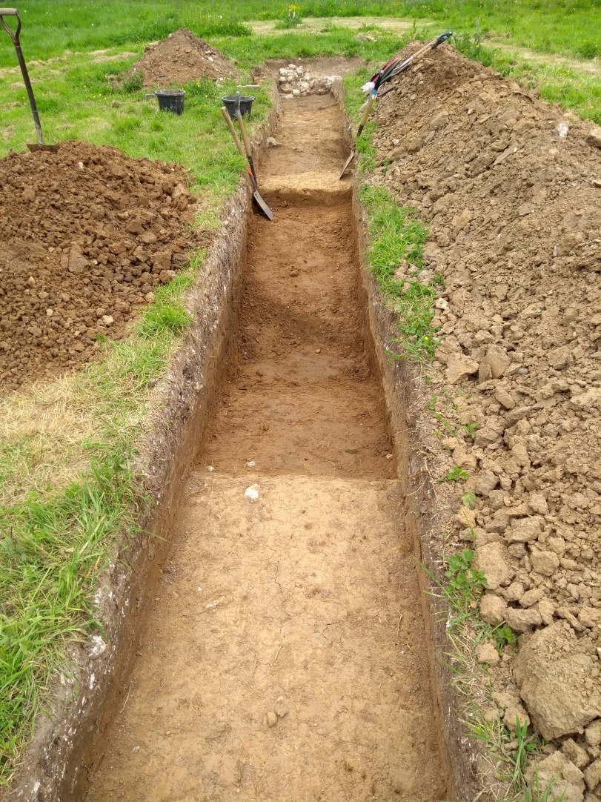

The ditch begins to emerge

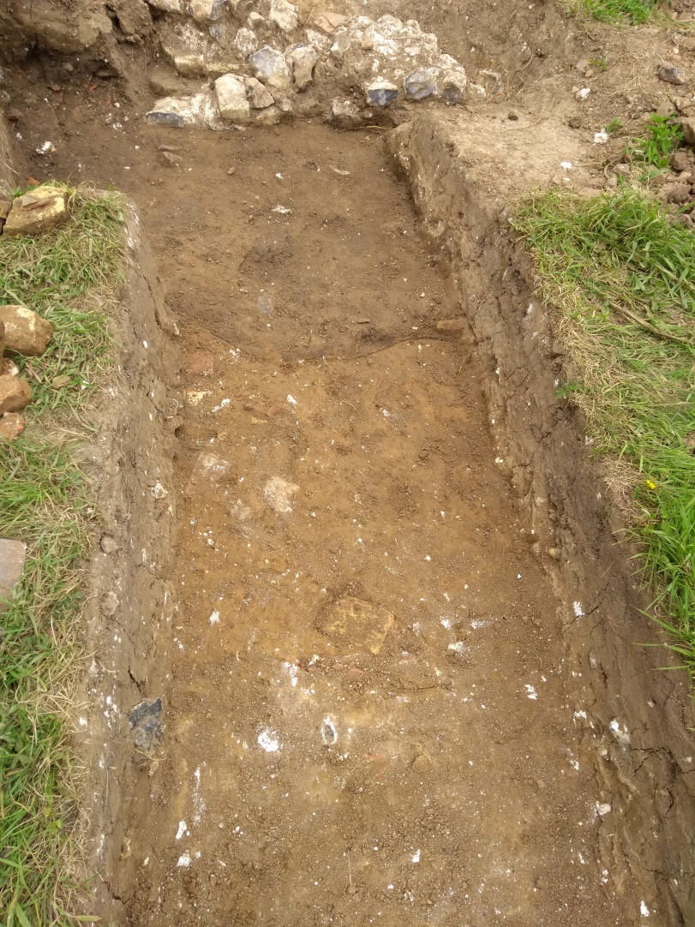

At the top the building, next what appears to be part of the darker soil of the building platform and at the bottom of the picture another feature, perhaps another ditch or a cut for another wall foundation?

More digging required and the answers in the autumn edition!

Our Man in Cornwall

I’m delighted to say I’ve received a contribution from Richard, he’s been hard at work again, this time near Looe and odd to say that I stayed very close to this site staying in a house in West Looe Hill, less than ½ a mile away and I’ve taken a picture of Looe island just as he did without me knowing what was hiding in the hill above me.

So, without further ado it’s over to Richard.

A Bronze Age barrow in Cornwall
April was apparently the season for digging Bronze Age barrows. DAG explored the barrow at Coxhill so, not to be left out, I joined a team digging a Bronze Age barrow at Hendersick Farm, overlooking the coast between Looe and Talland in Southeast Cornwall.

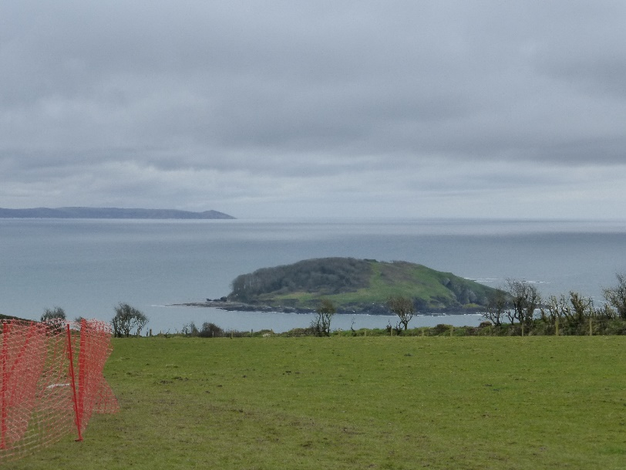
Looe Island from Hendersick Farm

The excavation was directed by Catherine Freeman, senior lecturer at the Australian National University, Canberra. As I frequently find with digs in Cornwall, the site was about an hour from my home in Tregony, although this time in an easterly direction - only 32 miles by road but the last few miles were narrow and the final mile was always very tense because if I met a vehicle coming in the opposite direction one of us would have to reverse quite a long way!
The project was to excavate a segment consisting of about a quarter of the entire barrow. On my first morning I was helping to mattock an area around the barrow centre when within ten minutes the digger next to me exposed a circle in the ground, just 25cm below the surface. The last time I saw a circle in the ground like this was in 2004 when I had just clipped the top off an Anglo-Saxon claw beaker with my spade, at Ringlemere. Fortunately, this time there was no accompanying ‘click’. So, after careful excavation a miraculously complete collared urn was revealed and then taken away by the local conservator for excavation in her lab. As anticipated it was found to contain cremated human bone. The find was doubly fortunate because it soon transpired that at a later date a large pit had been dug less than half a metre away, which contained many fragments of a medieval pot.

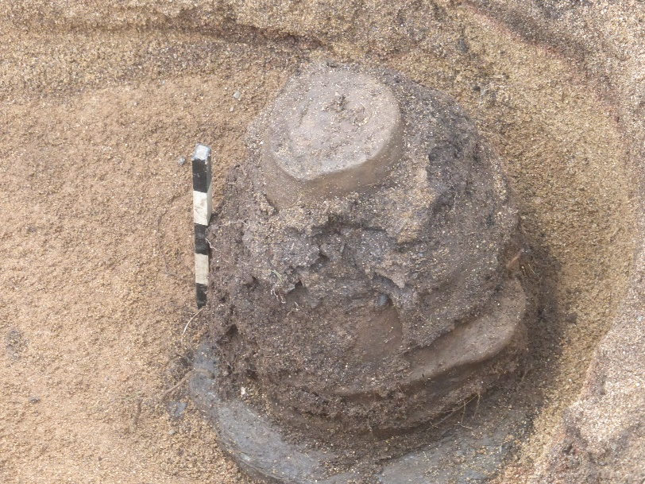
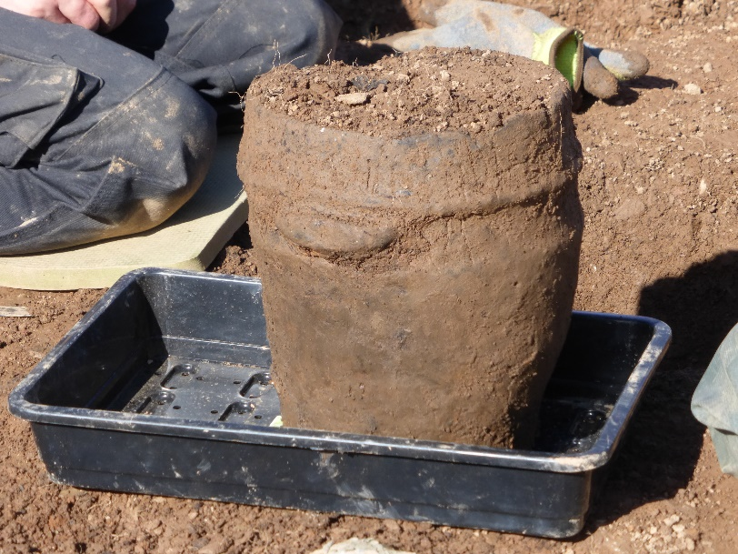

The ring ditch is about 16 metres in diameter, 1.20 metres deep and filled by yellow clay containing large quantities of broken shillet together with a small number of struck flints and pot-sherds. The location of the site was spectacular, overlooking Looe Island (also known as St George’s Island) where Time Team excavated an early monastic site in 2008.

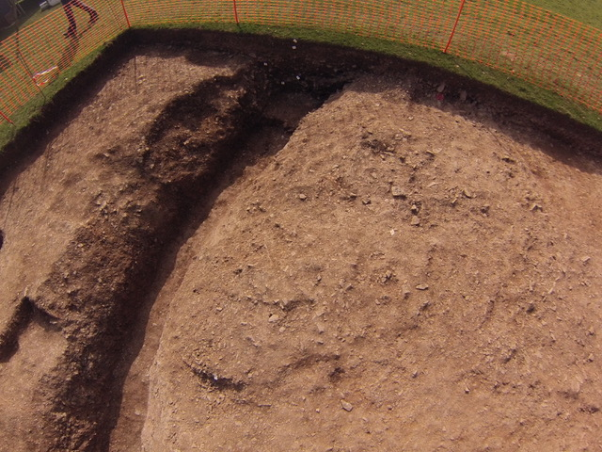

Another interesting aspect of the site is that from it we could see a pair of towers, one of two pairs which mark the ends of a Measured Nautical Mile, used by ships to calculate their speed.

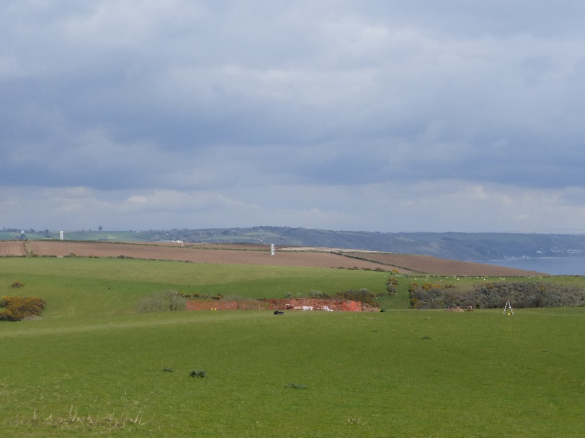

Strangely that this is the second BA barrow I have worked on since living in Cornwall and the second to produce a complete collared urn. The first was in December 2016 on the north coast at Constantine Bay where we also had a complete collared urn - inverted this time but also containing a cremation. I was beginning to think that this is standard procedure in these parts but have since been assured that these are the first two collared urns to be found in Cornwall for more than 20 years.

In the News

Stop Press at the Slatters Hotel Site

For those who have yet to go to Slatters site it will be open up to the end of July. Latest news is this week three skeletons have been found, one buried beside a Roman wall and all are believed to be Saxon in date.

Saxon cellared buildings have been excavated and an example is pictured below with Hazel doing the planning.

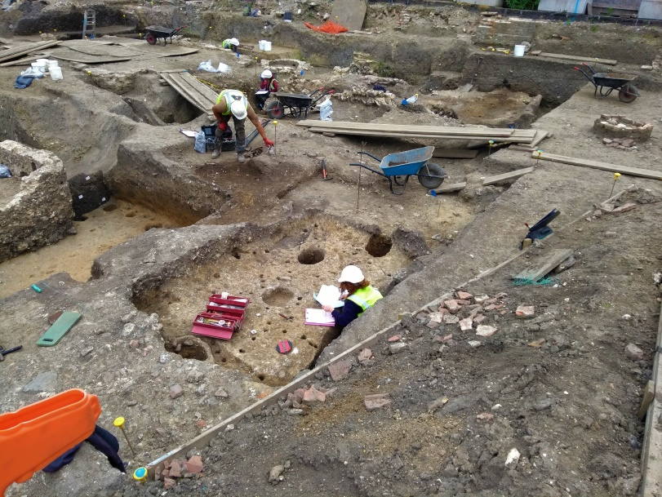

The KAS Landscape Project

Meanwhile what’s in store for the future? Well, what certain is the KAS project on Lady Sondes Estate. Keith will be leading a dig lasting three weeks from 1st September. It will cover the site of the Bronze Age hoards and the immediate surrounding area. So anyone signed up with the KAS project make some time to prepare and brush up on the Bronze Age. A little personal research on the internet or in your reference books can go a long way. There’s no telling what may turn up!

The CKA

And finally, word reached the Group recently that Brian Philp is proposing to announce that the CKA (Council for Kentish Archaeology), may be wound up. Typically, DAG hasn’t been contacted at this time regarding this decision. If it’s up for a member’s vote, which curiously involves DAG as an associated Group, (since 1971). The outcome is unclear but it would seem certain that members of the Council feel its run its course and superseded by the modern regional professional companies in the field.

The outcome will be published as soon as firm news comes through. On a personal note I had early fond memories of the CKA as it was one of the sponsors of the Dover digs in the 1970’s and also responsible for starting an award for young archaeologists, an idea begun in Kent and now extends throughout the UK. I was one was nominated for the award albeit belatedly and I received the award at the annual conference in about 1975. It’s a shame the CKA seems to have lost its way and couldn’t move forward to continue to contribute to the archaeological movement of today.

Well that’s all for now,

See you on the dig at Nonington or Lady Sondes Estate.

Gordon

